**Pre Ex Registration – Hippocampus**

A) In one Slicer open the Ex-Vivo ① - **MRI_ExHistReg.nii.gz**  
B) In another Slicer open the 7T ②

**Fiducial Placement** -- Minimum 10 fiducials!  
D) In the ① go to Markups module () on the tool bar 🡪 Create New Markups Fiducials as **Ex**

E) In the ② use the Markups module () on the tool bar🡪 Create New Markups Fiducials as **7T**

F) Place fiducials by clicking the blue arrow ()on the tool bar, then where you want to place the fiducial

1. You can change their color/size/opacity in Advanced options
2. Right click on fiducial-> JUMP SLICES
3. Make sure fiducials are corresponding on both images!

G) In 1st Save Fiducial list as **Ex.fcsv** in

EpilepsyDatabase/<SUBJ>/Processed/PreEx_Reg/Hp/Init_xfms (this will probably change)

H) In 2nd Save Fiducial list as **7T.fcsv** in

EpilepsyDatabase/<SUBJ>/Processed/PreEx_Reg/Hp/Init_xfms

Fiducial Registration

H) Load **Ex.fcsv** in 2nd AND **MRI_ExHistReg.nii.gz** in ②

I) Go to Modules > Registration > Specialized > Fiducial registration module:

Fixed: 7T

Moving: Ex

Save tfm: **some_name**   
Transform Type: Similarity or Rigid

(similarity can augment little errors but also does global scaling, you can make 2 tfm images with each transform type, and then check out both too see which one generally does a better job 🡪 I generally only use Rigid)

**Rigid Image Registration**

J) Go to Modules > Registration > Resample Image (BRAINS) module

1. Image to Warp: **MRI_ExHistReg.nii.gz**
2. Reference Image: **7T**
3. Output Image Create New Volume / Rename current volume -> **some_name** (this becomes the transformed image)
4. Warping Parameters --> Transform File: **some_name** (this is the transform file from the fiducial registration)
5. Interpolation mode --> Bspline
6. Apply

K) View/check registration in Modules > Transforms module

1. Active Transform: **some_name**
2. In the Apply Transform tab, move Ex from Transformable to Transformed via the arrows to view how the fiducials have changed
3. In the Slice viewers, view **some_name.nii.gz** in the foreground and the **7T** in the background, change opacity as needed

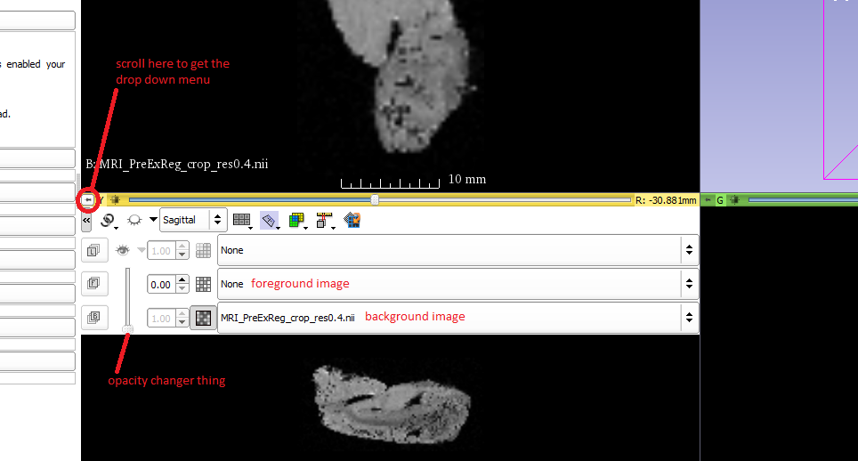

1. Go to Modules > Data module, find Ex under some_name
2. Right click on Ex and select Harden Transform, this makes the transformation permanent
3. Save as **Ex_transformed.fscv** in EpilepsyDatabase/<SUBJ>/Processed/PreEx_Reg/Hp/Init_xfms

L) Save transform as: **some_name.tfm** in

EpilepsyDatabase/<SUBJ>/Processed/PreEx_Reg/Hp/Init_xfms

M) Save output image: **some_name.nii.gz** in

EpilepsyDatabase/<SUBJ>/Processed/PreEx_Reg/Hp/Init_images

*SCRIPTS THAT ARE RUN THAT DO SOME THINGS THAT ARE NOT NECESSARILIY NECESSARY*

Run 2.0_concatRigXfms from the UNIX command line

Takes <SUBJ> <structure> >> Concatenates rigid warps for Pre-Ex registration

Run 3.1_NregWarpNeoToHist from the UNIX command line

Takes <SUBJ> >> Transforms cropped T1 map to Ex-vivo space for full registration

**note: name says wrap Neo to hist, but code was changed to do warping Hp to hist

**Deformable Image Registration**

Create and Apply Binary Mask

N) Create overlay binary mask for **MRI_PreExReg.nii.gz** in

EpilepsyDatabase/<SUBJ>/Ex/9.4T/Hp

1. Open **MRI_PreExReg.nii.gz** (this will probably change) in Fslview for intensity reference and shape reference. Keep this open until mask creation is finished.

2. In the Unix Command Terminal 🡪 get an idea for the starting point of your threshold via finding the lower 15 percentile of the image using:

fslstats <input> -P 15

input = **MRI_PreExReg.nii.gz**

outputs a number, that is your lower threshold

3. Generate masks from the terminal using:

fslmaths <input> -thr ### -bin <output>

input = **MRI_PreExReg.nii.gz**

output = **mask.nii.gz**

4. View **mask.nii.gz** in fslview

fslview mask.nii.gz

5. Brute force threshold using fslmaths and different threshold numbers until you find a mask that covers the original image well

If image is all black = threshold is too low

Increasing threshold decrease the noise

If threshold is too high, the mask may cut off bits of the original image

6. Stop when you get a good match

O) Apply mask using

fslmaths <input> -mas <mask> <output>

input = **MRI_PreExReg.nii.gz**

mask = **mask.nii.gz**

output = **MRI_PreExReg.masked.nii.gz**

To Install Plastimatch:

View > Extension Manager

In the window, search for the SlicerRT extension, and follow the instructions

Plastimatch Transform(Do in Windows)

P) Non-rigid registration

1. In Slicer load the data:

**Some_name.nii.gz**

**7T**

**Ex_transformed.fcsv**

**7T.fcsv**

1. Go to the Modules > Plastimatch > Registration > LANDWARP Landmark deformable registration module

Fixed Volume: **7T**

Moving Volume: **some_name.nii.gz**

Fixed Fiducials: **7T.fcsv**

Moving Fiducials: **Ex_transformed.fcsv**

Output Vector Field (MRML): Create new as **Plasti_Ex_T1**

Basis Function: Gauss

RBF Radius: 50.0

Stiffness: 0.1

1. Save **Plasti_Ex_T1** as a NifTi file --> **Plasti_Ex_T1.nii.gz**

*SCRIPT THAT DOES THE DEFORMABLE REGISTRATION*

Run 5_warpExToPreNonRigid from the UNIX command line

Takes <structure> <SUBJ> 🡪 deformable registration

Run 6_checkRegExToPre from UNIX command line

Takes <structure> <SUBJ> 🡪 Checks the quality of the registrations